1. [2 marks]

Given code:

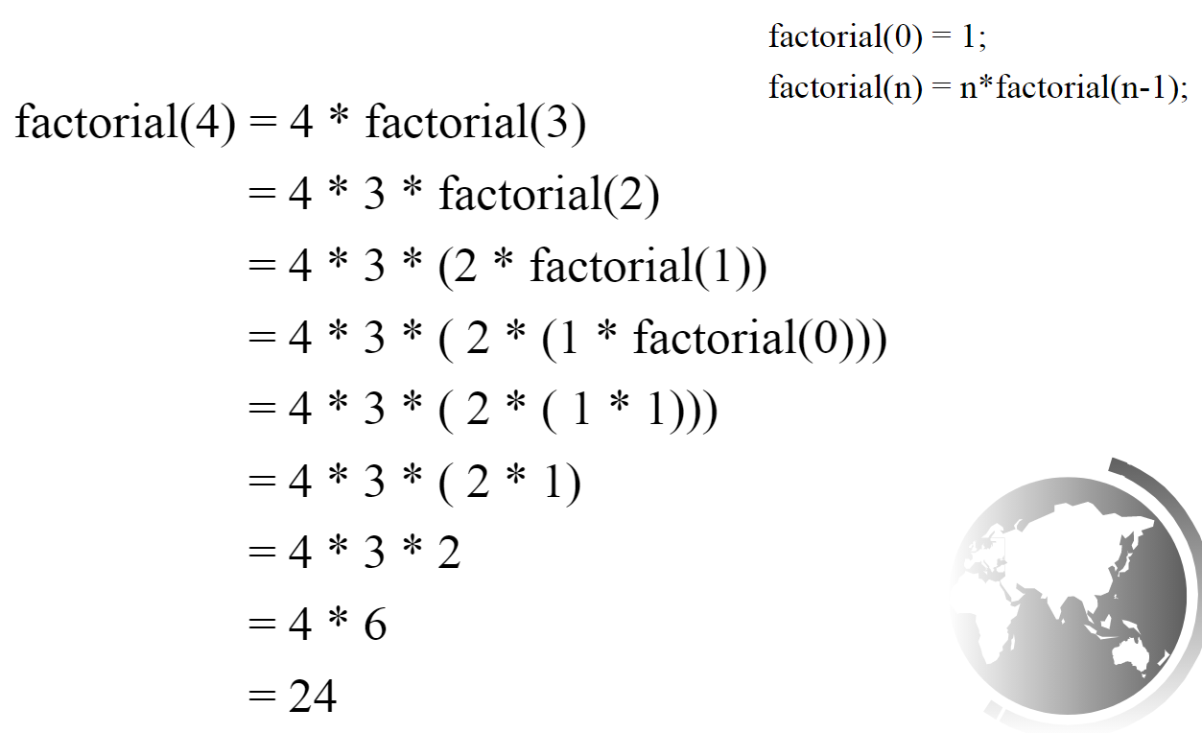

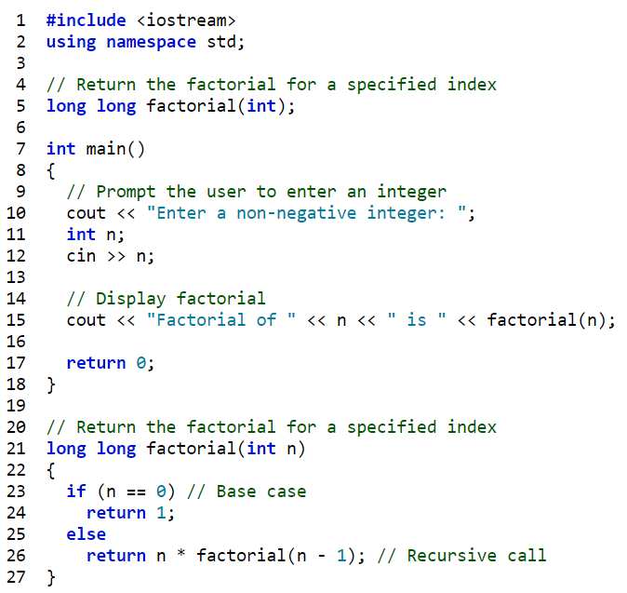

Reference site: <https://liangcpp.pearsoncmg.com/codeanimation/ComputeFactorial.html>

Tasks:

1. Analyze the code again.
2. Modify the function long long factorial (int n) to solve the problem using loop instead of recursion.

Filename: Lab3_1_yourstudentid.cpp

1. [2 marks]

Given code:

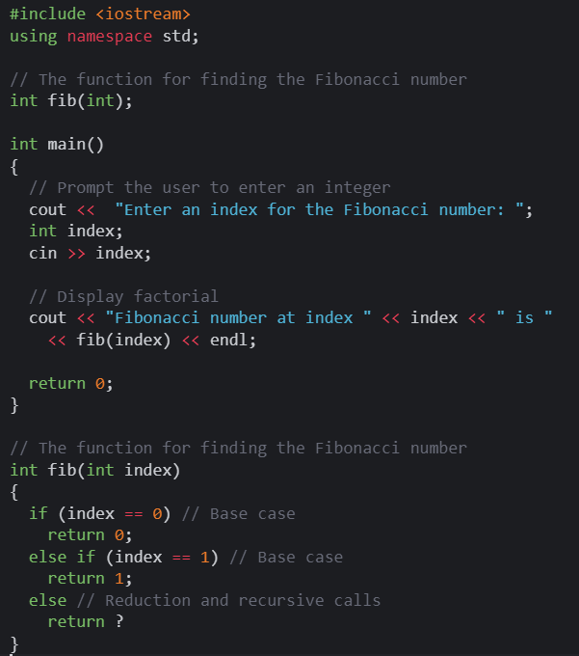

Task: Write an application with the complete solution. Hint: replace the ? with the proper calls to perform recursion.

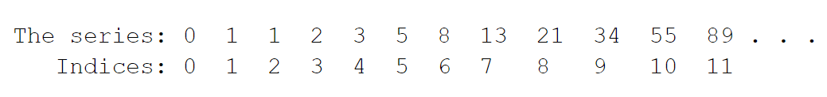

If the user enters 8, the output would be 21.

Filename: Lab3_2_yourstudentid.cpp

1. [2 marks]

Write a function called printStars. The function receives an int parameter. If the parameter is positive, the function prints (to console output) the given number of asterisks; otherwise, the function does nothing. The function does not return a value.

Thus, if the printStars(8) is called, ******** (8 asterisks) will be printed.

The function **must not use a loop of any kind (for, while, do-while) to accomplish its job**. Instead, it gets the job done by examining its parameter, returning if the parameter's value is not positive.

If the parameter is positive, it

* + prints a single asterisk (and no other characters)
  + then (recursively) calls itself **to print the remaining asterisks**.

Filename: Lab3_3_yourstudentid.cpp